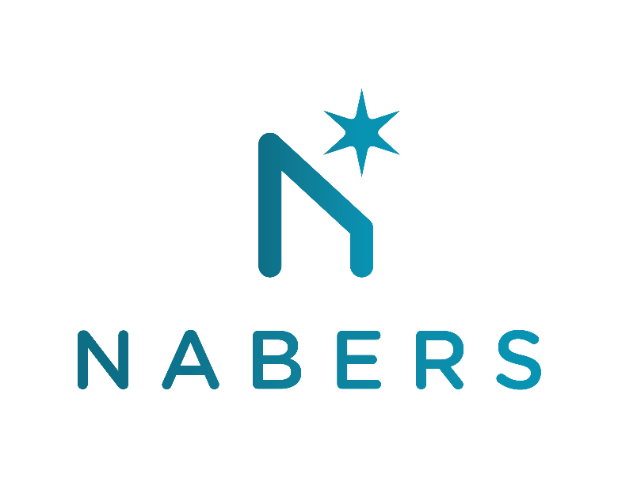

NABERS Carbon Neutral technical guidance
Consultation response form

Thank you for responding to the NABERS Carbon Neutral guidance document.
Please provide your feedback in this document and return in word (.docx) format to nabers@environment.nsw.gov.au.
Please return your responses by COB Tuesday 10th October 2023.

NABERS is administered by the New South Wales Government
Organisation: Enter your organisation’s name here

Section | Question | Comments
Section 2 Update on Waste guidance | - Do you have any comments on the above updates about declaration of waste data quality? | Enter your responses to the questions in this table
 | - Do you have any feedback on the Waste collection data that does not satisfy NABERS Waste requirements?
 | - Do you have any feedback on the proposed implementation of scaled emissions based on waste data quality?
 | - Do you have any comments on the update for formal waste rating or collection of data in accordance with the NABERS Waste verification rules is considered as pre-requisite for a carbon neutral claim via the NABERS-pathway?
 | - Do you have any feedback on the proposed recommendation for assessors being accredited in Waste rating tool for them to proceed for CN accreditation?
 | - Do you have any feedback on the proposed recommendation for assessors being accredited in Waste rating tool for them to proceed for CN accreditation?
Section 3  Update on Refrigerants guidance | - Are you in favour of proposed methods for accounting of refrigerant emissions? Would you use it or recommend it?
 | - How well does these methods resolve the scenario for zero % claim for refrigerant leaks? Please share your feedback.
 | - What are your comments regarding development of Refrigerant Gas Equipment Maintenance Register?
 | - What are your comments regarding having a Statements from maintenance contractors for refrigerant addition in a given period under method 2?
- Do you support NABERS’ approach for
- Refrigerant emissions accounting methods over multiple years
- Account for all refrigerant with GWP greater than zero
- Materiality with respect to refrigerant gas emissions

Section 4  Update on Mixed-use building guidance | - Are you in favour of the proposed changes?
 | - Do you have any other feedback on the proposed changes?
Section 5  Documented evidence requirements | - Are you in favour of the proposed changes?
 | - Do you have any other feedback on the proposed changes?
 | - Do you foresee any issues in obtaining the required documents and information as per the above?
Section 6  Other updates | - Are you in favour of the proposed updates?
 | - Do you have any other feedback on the proposed updates?

If you have any other feedback or context related to this consultation that you would like to provide, please add it here:

